- Completed career exploration guide
- 10 job ads printed and numbered to correspond with skills matrix
- Print out the salary bell curve for your job title from Salary.com
- 3 informational interviews
- Current/updated resumé

Career Exploration Guide
Career Exploration Guide

Name: Date:

This guide is a tool to help you explore and collect relevant information so that you can determine the feasibility of your career choice, your training needs, and your future income. Take the time to thoughtfully and thoroughly answer these questions. Remember, this is your future.

Focus
1. What is the title of the occupation you are investigating?
a. What are related names for this position?
b. Is this a skill upgrade or a career change?

Information about the position
2. What does a typical workday look like?

- Do you have any experience that could transfer into this position?

b. If you are making a career change, why do you want to enter this new field? What excites you about the field and what are some challenges you may face?

Salary Information
3. What is the minimum hourly wage you must make to meet your normal living expenses?
a. How many years of work experience do you have in the field you are researching?
b. What is the pay for this job at your level?
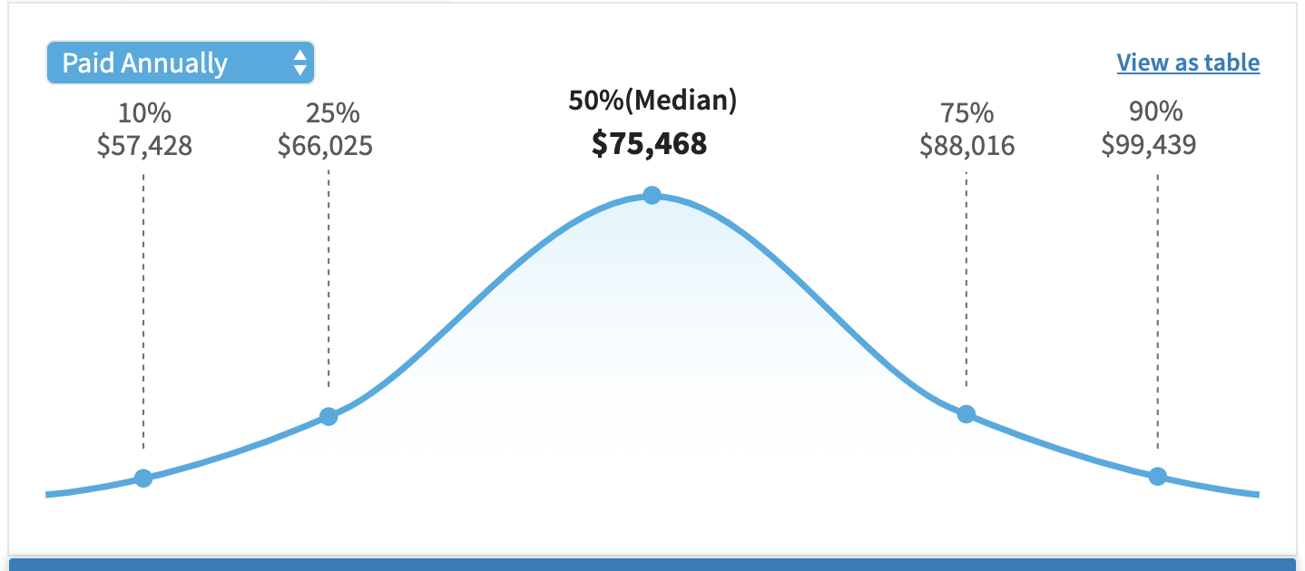
Print out salary bell curve for this job title from Salary.com
• Range: $ to per hour
- Annual salary: $ (hourly wage x 2,080 hours)

Local Labor Market
What skills, education, and experience do I need to be marketable?
- Collect 10 detailed job postings for the same job title/function (use more job postings
for a more detailed matrix); list them on the Skills Matrix: Job Descriptions page (p.3).
- Complete the Skills Matrix (p.4):
  - List all skills mentioned in the postings and identify which postings require which skills;
  - Determine whether you possess the skills and education required for each postion.
- Attach the job postings at the end of this Career Exploration Guide or paste the job posting URLs on the Skills Matrix: Job Descriptions page (p.3).

Skills Matrix: Job Descriptions

Paste the URL for each of your 10 identified jobs’ online job ad in the respective field below.

Job 1: Title/Company:
URL:

Job 2: Title/Company:
URL:

Job 3: Title/Company:
URL:

Job 4: Title/Company:
URL:

Job 5: Title/Company:
URL:

Job 6: Title/Company:
URL:

Job 7: Title/Company:
URL:

Job 8: Title/Company:
URL:

Job 9: Title/Company:
URL:

Job 10: Title/Company:
URL:

Skills Matrix

Is it realistic for me to think that I can become employed in the job I am researching in my targeted location? Use 10 related job ads to determine the skills, education, and experience required to apply for these positions. Include both technical and soft skills.

Current Skills + Training = Preparation to effectively compete for these jobs
Required  Skills | Job  1 | Job  2 | Job  3 | Job  4 | Job  5 | Job  6 | Job  7 | Job  8 | Job  9 | Job 10 | I Have Skill | I Need Skill
Years of Experience
Level of Education

Informational Meetings [Future Contacts]

We ask that you speak to three (3) people who are knowledgeable about the current labor market and the position for which you are seeking training (hiring managers, recruiters, someone doing the job). Use the attached worksheets to record the following information for each of the interviews.

- Name of person interviewed
- Current position & company

Ask your contacts the following questions:
- What are your current job responsibilities/tasks?
- What skills, certifications, and education are required for this job today?
- Inform your contact of your current background and ask,
“With my background, what challenges will I face in finding a job in this field?”
- What do you recommend I do to help me get a job in this field?
You may ask and include information from the additional questions at the end of the workbook.

Attach your resumé to this Career Exploration Guide.

- If you have skills and experience related to the training that you are requesting,
include it on your attached resumé.
- If you are entering a new field (career change), include your existing resumé —
you do not need to customize the resumé for the field in which you want training.

Informational Meeting 1

Contact information:

Full Name Company
Job Title

- What are your current job responsibilities/tasks?

- What skills, certifications, and education are required for this job today?

- Inform your contact of your current background and ask, “With my background, what challenges will I face in finding a job in this field?”

- What do you recommend I do to help me get a job in this field?

- Anything else that you think that I should know about this field or needed training?

Informational Meeting 2

Contact information:

Full Name Company
Job Title

- What are your current job responsibilities/tasks?

- What skills, certifications, and education are required for this job today?

- Inform your contact of your current background and ask, “With my background, what challenges will I face in finding a job in this field?”

- What do you recommend I do to help me get a job in this field?

- Anything else that you think that I should know about this field or needed training?

Informational Meeting 3

Contact information:

Full Name Company
Job Title

- What are your current job responsibilities/tasks?

- What skills, certifications, and education are required for this job today?

- Inform your contact of your current background and ask, “With my background, what challenges will I face in finding a job in this field?”

- What do you recommend I do to help me get a job in this field?

- Anything else that you think that I should know about this field or needed training?

Your time and resources
6. What are some obstacles that could interfere with your training or job search?
None Caring for children/elders Family responsibilities
Part-time job Volunteer work Outside Activities
Travel Health conditions Other
How will you manage these potential obstacles?

a. Do you have access to the technology required for online or distance learning? Yes No
b. How will you financially support yourself while in training and/or job search?
Family/Spouse Part-time job Severance
UI Benefits: If “UI,” when did benefits begin?
Did you declare an interest in training prior to week 16 of your claim? Yes No
Other

c. Based on your financial situation, how many months can you commit yourself to training and/or job search? (Note: Training could take 3–12 months in addition to job search, which could take 3+ months.)

